MGMT640 - Financial Decision Making for Managers
MGMT 640 Lecture 9: Cost-Volume-Profit-Analysis

Learning Objectives
- Identify types of costs.
- Evaluate profit using the break-even point and contribution margin equations.
- Use account analysis and the high-low method to estimate the relationship between cost and activity.
- Perform cost-volume-profit analysis for single products.
- Perform cost-volume-profit analysis for multiple products.
- Discuss the effect of operating leverage.

Learning Topics: Types of Costs, Cost-Volume-Profit Analysis, Break-Even Point, Contribution Margin, High-Low Method
The focus of this week is to help you understand the assumptions of Cost-Volume-Profit (CVP) and how it is used in making and implementing managerial decisions.

Types of Costs
Variable costs are costs that vary with changes in activity (e.g. water expense). Variable costs can be estimated by taking the change in cost and dividing it by the change in activity.

Fixed costs do not change in total as activities change (e.g. rent expense). Discretionary fixed costs are those fixed costs that management can easily change in the short-run (e.g., advertising). Committed fixed costs are those fixed costs that cannot be easily changed in the short-run (e.g., rent).

Relevant range describes a limited span or volume of activity (i.e. minimum and maximum parameters). Fixed costs do not change within the relevant range. Cost functions within the relevant range are assumed to be linear.

Mixed costs have a component of both variable and fixed costs (e.g. copy machine costs; there is a fixed price for renting the equipment and a per copy charge for each copy).

Step costs are costs that change outside of a defined activity range. If activity is maintained within certain defined limits, the incurred costs remain constant. But, once the activity level passes those limits, costs increase or decrease (based on increased or decreased activity levels). With graphical depiction, the costs are depicted with a stepwise pattern.

Sunk costs are defined as costs that have already been incurred and cannot be recovered.

Opportunity costs are alternative costs. This is the value of a forgone activity.

Cost-Volume-Profit
Cost-Volume-Profit analysis is a powerful tool used to assist managers in their decision-making process. It examines the relationship between revenues, costs, and income based on volume of activity. It answers questions like: What effects on profit can be expected if JetBlue adds a flight on the route from New York to Orlando? How many patient days must a physician’s office have to break even for the year? How many cars does a dealer need to sell to cover all of their expenses?

Break-Even Point:
The first step is to calculate the break-even point. The break-even point is the volume of activity where revenues equal expenses, meaning no profit or loss is made. The break-even point can be calculated by using the profit formula approach or the contribution margin approach.

Profit = Selling Price (x) – Variable Costs (x) – Total Fixed Cost
Where (x) indicates the number of units.
When Profit = 0, the Break-Even Point occurs. Therefore,
0 profit (i.e. break-even point) = Selling Price (x) – Variable Costs (x) – Total Fixed Cost

Contribution Margin and the Break-Even Point:
Break-Even Point = Fixed Costs / Contribution Margin per Unit

Contribution Margin:
Contribution margin is the difference between sales and variable costs. The contribution margin can be expresses as a total or at the unit level. The unit contribution margin is the difference between unit sales price and unit variable cost.

Contribution Margin per Unit = Sales Price per Unit – Variable Cost per Unit

Total Contribution Margin = Total Sales – Total Variable Costs

The contribution margin ratio is the contribution margin expressed as a ratio or converted to a percentage of sales. It can be calculated on a total or per unit basis.

Contribution Margin Ratio = Total Contribution Margin / Total Sales

Contribution Margin Ratio = Contribution Margin per Unit / Sales Price per Unit

Margin of Safety
When looking at the break-even point, we also consider the margin of safety. The margin of safety is the difference between actual or budgeted sales and the break-even point.

Margin of Safety = Expected Sales – Break Even Sales

Martin of Safety Ratio = Margin of Safety / Expected Sales

Multiproduct Analysis
Cost-volume-profit analysis can be performed when a company produces and sells multiple products. If the products sold are similar, the weighted average contribution margin per unit can be used in cost-volume-profit analysis. The weighted average contribution margin per unit depends on the sales mix.

If the mix is 2 units of Product A to 1 unit of Product B and their respective Unit Contribution Margin's are $15 and $30, the weighted average contribution margin per unit (WACM) is calculated as follows:

WACM = 2 ($15) + 1 ($30) = $20 per unit

The break-even point (BEP) in units is:

BEP in units = Fixed Costs / WACM per unit

In order for Cost-Volume-Profit analysis to work the following assumptions must be followed:
- Revenue is linear, meaning that the sales price will not change as volume changes.
- Expenses are categorized into variable, fixed, and mixed.
- The sales mix remains constant over the relevant range. Relevant range is the normal operating range for a business.

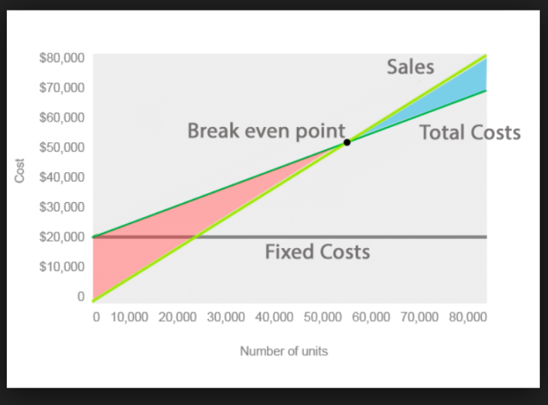
Cost-Volume-Profit example chart

When the products sold are substantially different, Cost-Volume-Profit analysis should be performed using the contribution margin ratio (CMR).

a. The break-even point calculated using the CMR is only good for the sales mix that the CMR is based on.

b. The CMR used is the CMR for the overall segment or company, i.e., overall CM divided by overall sales.

c. The break-even point in sales dollars is:

BEP in sales dollars = Total Fixed Costs / Overall CMR

Operating Leverage
Operating leverage relates to a company's cost structure, i.e., the amount of fixed costs in relation to the amount of variable costs. The level of operating leverage is important because it affects the change in profit when sales change. Due to fixed costs in the cost structure, when sales increase or decrease by 10%, profit will increase or decrease by more than 10%. The greater the level of fixed costs in relation to variable costs, the higher the operating leverage. Firms with high operating leverage are more risky because they have large fluctuations in profits when sales fluctuate. Companies that have relatively higher fixed costs are said to have higher operating leverage. Thus, a software company with a large investment in research and development (a fixed cost) would likely have higher operating leverage compared to a manufacturing company that used little equipment but expensive labor (a variable cost).

Constraints
When limitations or constraints exist, only a limited number of units can be produced. To determine which products should be produced in this situation, the key is to determine the contribution margin per unit of the constraint. In order to maximize profits, a firm usually wants to produce those products with the highest contribution margin per unit of constraint. However, the laws of supply and demand impact total profits.

Example: Assume Product A has UCM of $200 and Product B a UCM of $100. If Product A takes 10 hours and Product B 2 hours to produce, their respective contribution margins per hour are:

Product A: $200/10 hours = $20 per hour

Product B: $100/2 hours = $50 per hour

Therefore, Product B should be produced first, until demand is satisfied and then Product A should be produced.

Cost Estimation Methods are used to determine which costs are fixed and variable in order to use them to calculate the break-even point and Cost-Volume-Profit.

Account Analysis is most widely used. With account analysis, managers use judgment to classify costs as either fixed or variable. The total of the costs classified as variable can then be divided by a measure of activity to calculate the variable cost per unit of activity. The total of the costs classified as fixed provides the estimate of fixed cost.

High-Low Method uses activity and cost information from previous periods. This method separates the fixed and variable cost elements of a mixed cost. Search the data set for the highest level of activity and the lowest level of activity. The highest cost may not occur at the highest activity level and the lowest cost may not occur at the lowest activity level. Therefore, find the highest level of activity and then look at the associated cost. Find the lowest level of activity and then look at the associated cost.

Estimate of Variable Cost = (Cost at its highest level of Activity - Cost at its lowest level of Activity) / (# units at highest level of Activity - # units at lowest level of Activity)

Scatter Graphs display past costs and unit data in graphical form.

Regression Analysis is a statistical method of identifying cost behavior. In simple linear regression, a straight-line fit is assessed on the scatter graph of plotted data. The correlation coefficient, R, indicates correlation between dependent and independent variables. If there is no relationship, R=0. If a linear relationship exists, R=-1 (perfect negative linear relationship) or R=1 (perfect positive linear relationship). R² is a measure of variance. When R²=0, the model doesn’t fit. If R² =0.5, 50% of the variance is from the predictor variable (i.e. independent variable); the model fits fairly well. The intercept is an estimate of the fixed cost and the slope is an estimate of the unit variable cost.

Product Costs
Product costs consist of direct labor, direct material and overhead. There are three methods that can used to allocate overhead: single plant rate, multiple plant rate (both of these are considered traditional), and activity-based costing.

Plant Wide Overhead Rate (single plant rate) uses volume related measures like: direct labor hours, direct labor dollars, or machine hours.

Departmental Overhead Rate (multiple plant rate) is used when there are multiple products that consume resources in different ways, therefore it uses a different overhead rate for each production department.

Activity-based costing assigns overhead cost based on activities. The premise is that the activity (task, operation, or procedure) will cause the cost to be incurred. This system is very complicated and expensive to implement, but considered by many the most accurate. (Lecture 10 will provide explore activity-based costing.)

